Mapping the improvement and assurance framework for local government

Purpose of Report
For direction.
Is this report confidential? No

Summary
Engagement with the local government sector is underway to map the improvement and assurance framework for local government. Board members are asked to consider questions which are also being considered by the wider sector, to inform the preparation of a draft framework for consideration by the Board at its October meeting.
LGA Plan Theme: Legal and governance support

Recommendations
That Board members:
- Consider questions set out in point 10 as part of sector-wide engagement to map the improvement and assurance framework for local government.
- Provide more detailed responses to questions, including consideration of the draft framework map, via the LGA website.
- Agree to delegate to Lead Members the approval of the LGA’s response to the Government’s consultation on statutory guidance for local authorities on the Best Value duty.

Contact details
Contact officer: Heather Wills
Position: Principal Adviser (Improvement)
Phone no: 07770 701188
Email: heather.wills@local.gov.uk

Mapping the improvement and assurance framework for local government
Background
- The Corporate Peer Challenge (CPC) report for the LGA in December 2022 included a recommendation that the LGA:
Lead the design of a reshaped sector support and assurance framework for local government, reflecting the different needs seen across the sector now.
- The LGA Board accepted this and all other recommendations arising from the CPC report at its meeting in April 2023.
- The LGA Board noted that there is no clearly defined assurance framework for local government. Whilst there are many checks and balances that are in place such as the role of the statutory officers; scrutiny; audit; requirement for an annual governance statement; much of our improvement work; inspection of key services; and ultimately the ballot box, none of this is brought together in one place for councils to understand and be clear they are sighted on it.
- Officers are now working with the sector, professional associations and others to lead and develop an improvement and assurance framework for local government and to consider:
- how the many checks and balances in the existing framework could be improved and simplified or enhanced to provide greater assurance for the sector;
- the potential to develop the framework further to become a sector support and assurance framework, clearly articulating the role of our sector support programme within the framework and ensuring that our support is more embedded within the wider improvement architecture for local government.
- The initial aim is to describe the assurance framework which currently exists – but is not yet written down – for the local government sector, in the interests of clarity and transparency and to aid understanding of how they all fit together. Since the scope and objectives of the sector are so wide-ranging, work will mainly focus on corporate rather than service-specific sources of assurance.
- The map will identify the elements which provide essential assurance in all councils: each council will additionally identify their own local objectives for which they are accountable to their local electorate.
- A Sounding Board, comprising representatives from CIPFA, SOLACE and Lawyers in Local Government, is providing advice on plans for engagement with the sector and analysis of feedback from that engagement.
- A programme of engagement with the sector is currently underway to inform the framework development – involving leaders and chief executives in all regions, lead and regional member peers, professional bodies and the trade press. A discussion is also being held with representatives of DLUHC.
- DLUHC has recently issued draft statutory guidance for local authorities on the Best Value Duty for consultation with a closing date of 15 August 2023. The guidance seeks to provide greater clarity on what constitutes best value, the standards expected by the department, and the models of intervention at the disposal of the Secretary of State in the event of failure to uphold these standards. Officers will review the draft guidance to understand any areas of commonality with the draft improvement and assurance framework. Members are asked to delegate to Lead Members the approval of the LGA’s response to this consultation.
Questions for the Board to consider
- Officers have drafted a definition of ‘assurance’ for discussion with the wider sector as follows:
Information about how local authorities are delivering their duties and functions, which can be used to hold them to account.
a) In auditing, assurance generally refers to the validity and accuracy of a council’s documents and information about the correctness and fairness of its processes, and its overall performance;
b) Reassurance is the act of addressing and removing specific doubts that have been raised about the correctness and fairness of a council’s processes and/or performance;
c) Accountability tends to be used in precise, specific and personal ways. This can include:
- accountability of elected members to their constituents
- accountability of officers to the Council (in terms of adherence to agreed policy)
- accountability of individual officers to the Council (in terms of their management)
d) The relationship between principals and their agents is based on being held to account, largely through the threat of dismissal (the public to their elected representatives, the Council to its employees and suppliers). In response to this potential threat, agents regularly give an account of their practice and performance to their principals.
11. Lead members are asked to consider the following questions:
(i) What are your views on the definition of assurance at para 9, above?
(ii) Do you have any suggestions for amendments to this definition?
- An early draft of a map of the local government improvement and assurance framework appears at Appendix 5A. Board members are asked to consider questions relating to the draft map which appears on the LGA’s website (or search ‘assurance framework’).
Implications for Wales
- Officers are liaising with the Welsh LGA to understand mechanisms for assurance and accountability in Welsh local government to enable comparison of best practice for mutual benefit.
Financial Implications
- Work to map the improvement and assurance framework for local government is funded by the DLUHC local authority sector support grant for 2023-4.
Equalities implications
15. It is intended that the improvement and assurance framework will support councils to consider how to assure themselves and their residents of compliance with all relevant legislation, including the Equality Act 2010.
Next steps
- The programme of engagement with the sector will run until the end of August after which the feedback will be analysed and reported to Improvement and Innovation Board and LGA Board in October 2023.
- Members will be asked to consider a recommendation for a second phase of engagement with the sector to consider the potential for improvements to the current framework. If agreed, this engagement would take place between November 2023 and February 2024, with the findings reported back to the Improvement and Innovation Board and the LGA Board in May 2024.

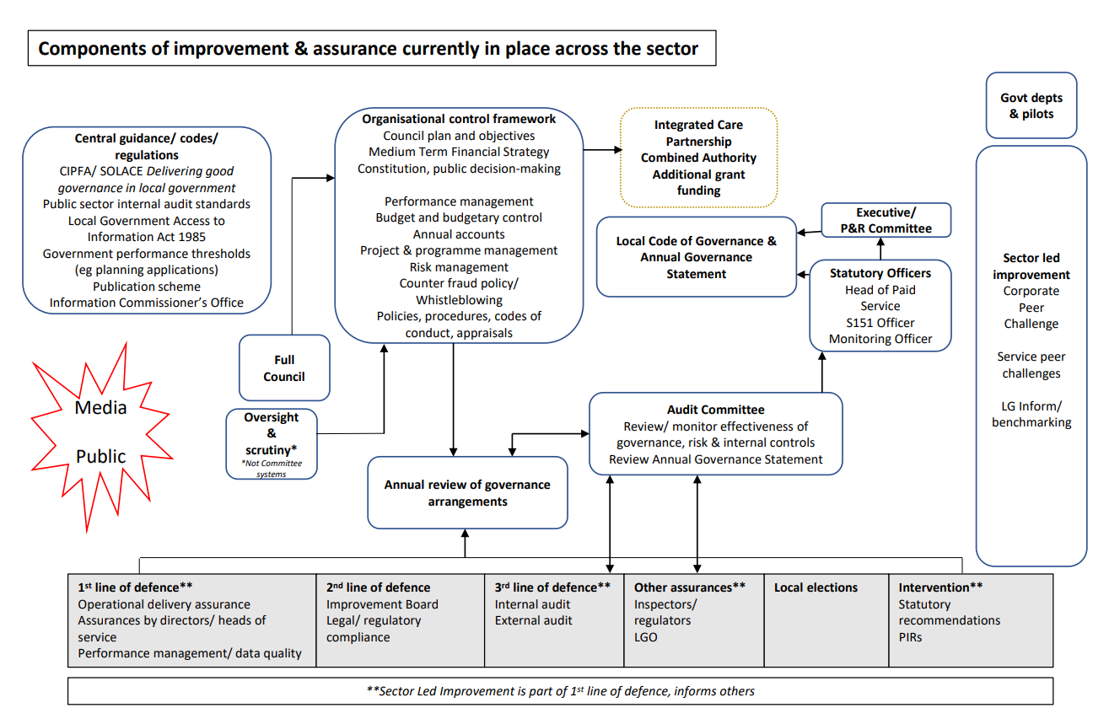
Appendix 5A

